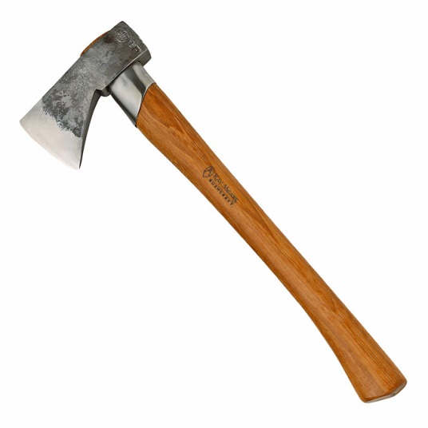 | AXE  - For cutting down trees
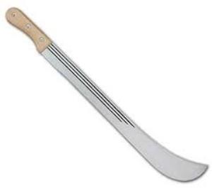 | CUTLASS  - For weeding  - For cutting down small trees  - For planting seeds  - For harvesting some crops
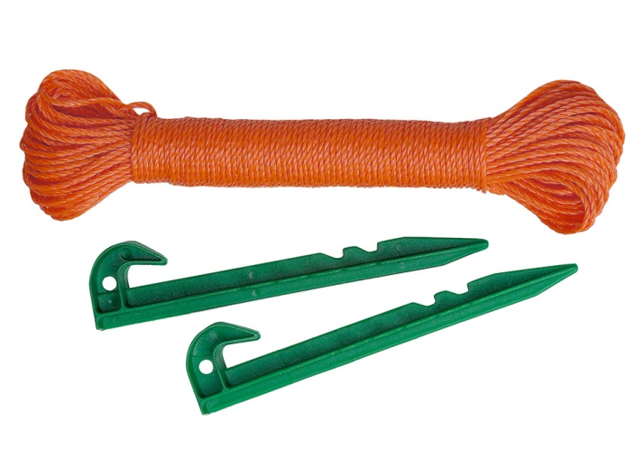 | GARDEN LINE OR ROPE  - For making out plot and planting crops in straight lines  - For straightening edges of plots
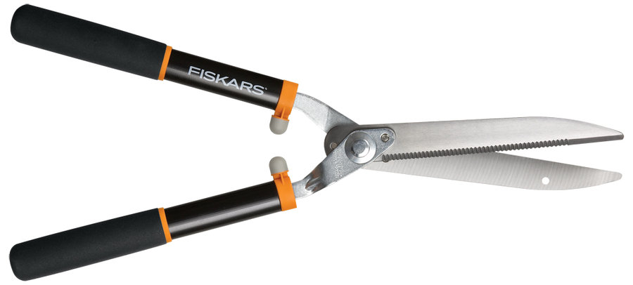 | GARDEN SHEARS  - For cutting and trimming hedges
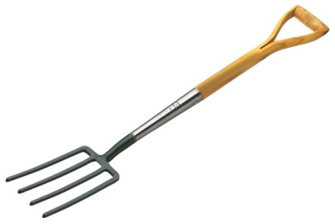 | GARDEN FORK  - For spreading manure in the open field  - For stirring or mixing compost  - For loosening the soil  - For uprooting stumps
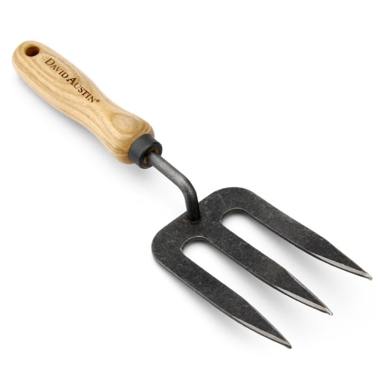 | HANDFORK  - For stirring the soil  - For digging up weeds from beds
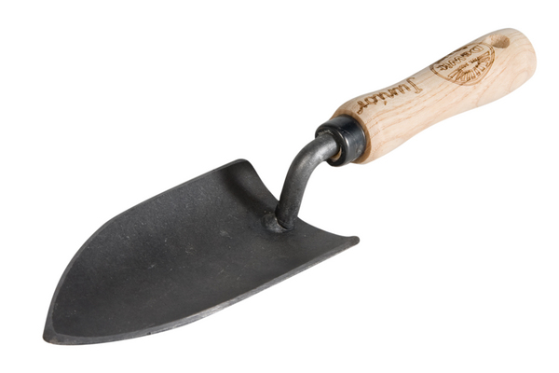 | HAND TROWEL  - For transplanting seedlings  - For earthing up vegetable crops on beds
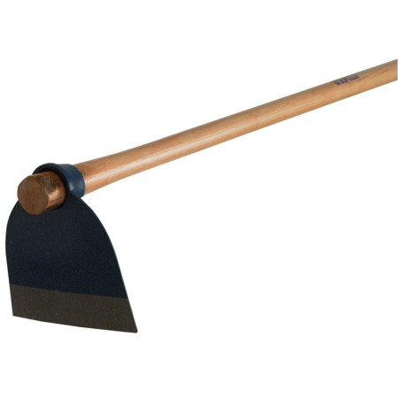 | HOE  - For weeding  - For making mounds  - For planting crops
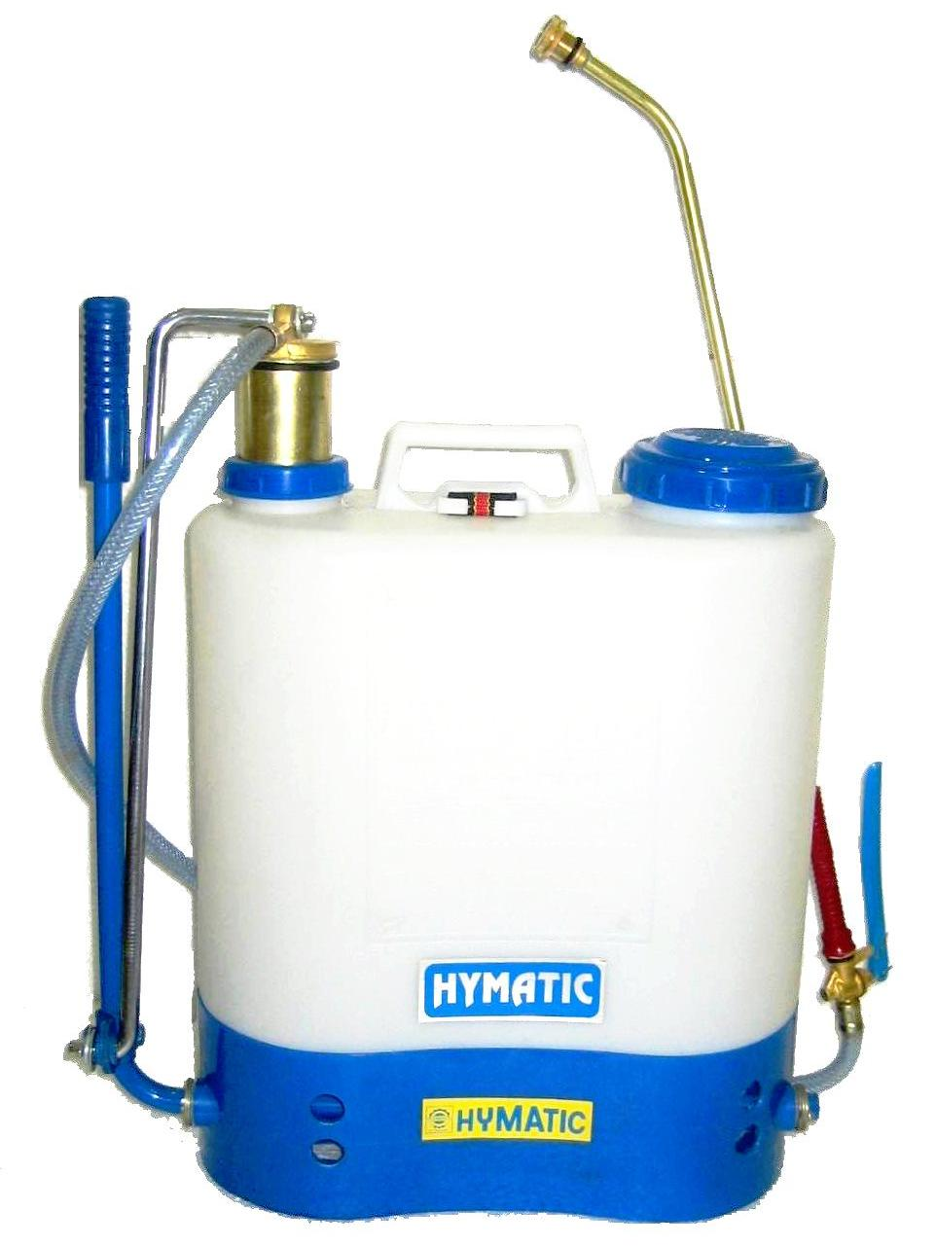 | KNAPSACK SPRAYER  - For spraying chemical solutions on crops
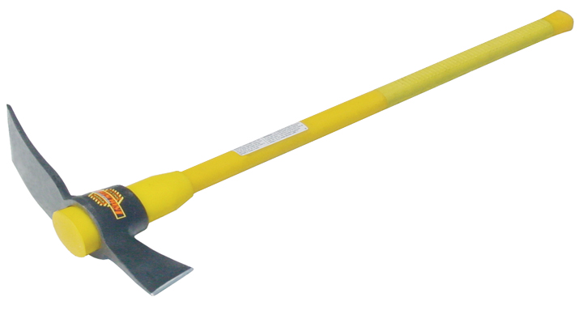 | MATTOCK  - For digging  - For uprooting stumps
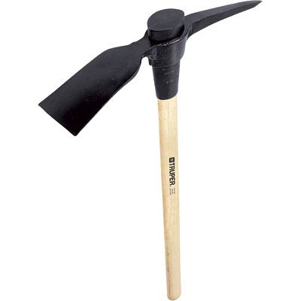 | PICK AXE  - For uprooting tree stumps and stones  - For loosening and digging the soil
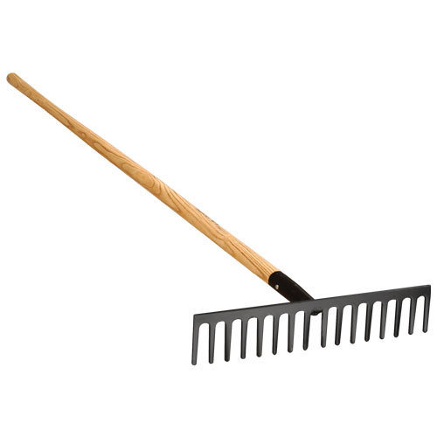 | RAKE  - For leveling soil surface  - For breaking large lumps of soil  - For gathering mulch or rubbish
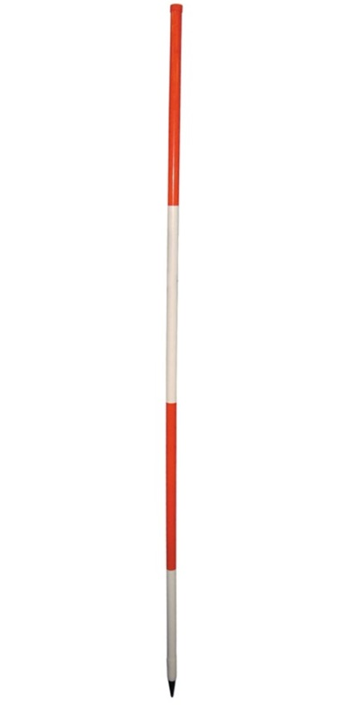 | RANGING POLE  - For making straight lines during line survey
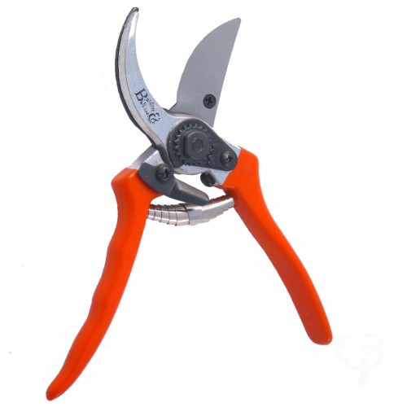 | SECATEURS  - For pruning diseased plant parts  - For cutting small branches for propagation
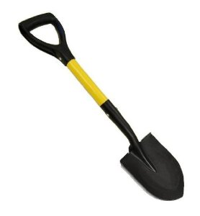 | SHOVEL  - For scooping and transferring soil/ stones during land preparation
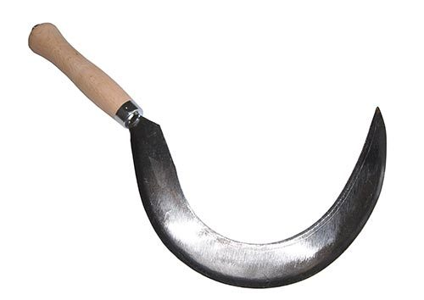 | SICKLE  - For harvesting cereal crops eg. rice  - For cutting grass
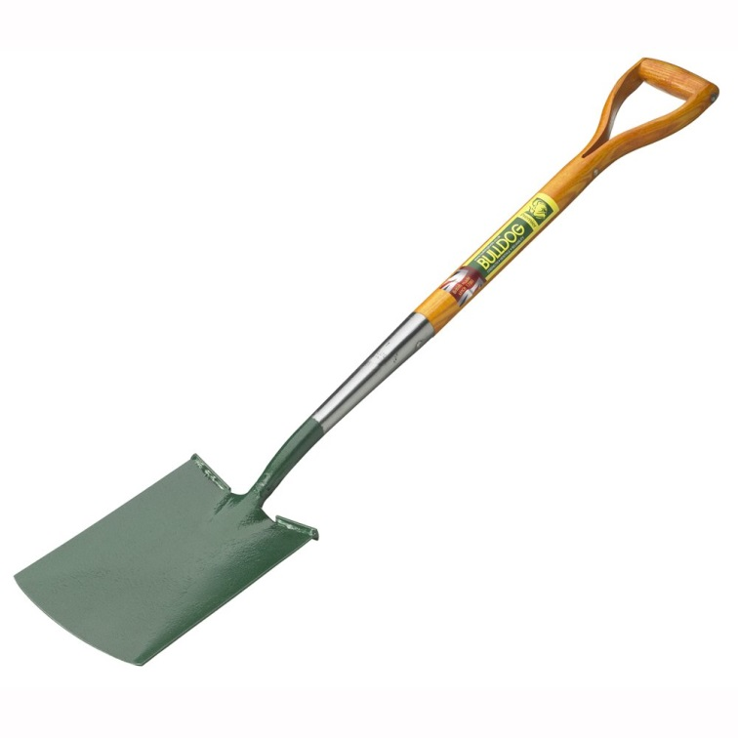 | SPADE  - For turning over soil
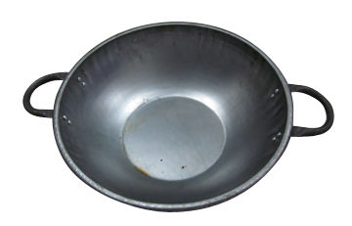 | HEAD PAN  - For carrying harvested crops  - For mixing fertilizers
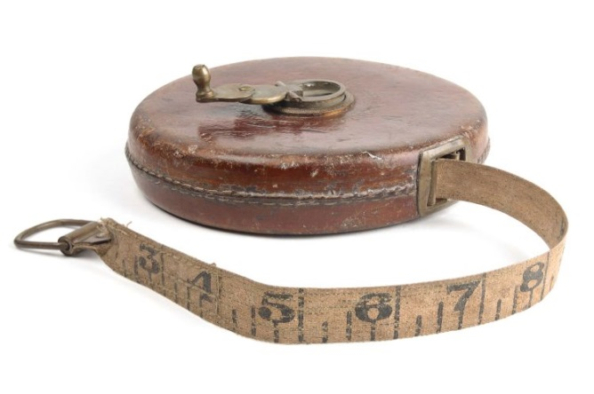  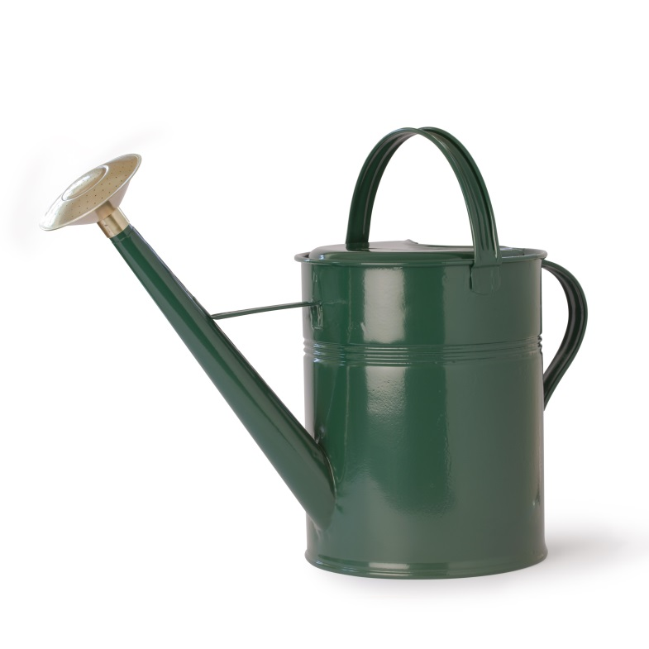 | SURVEYORS TAPE  - For taking measurements on the farm
WATERING CAN
- For watering crops
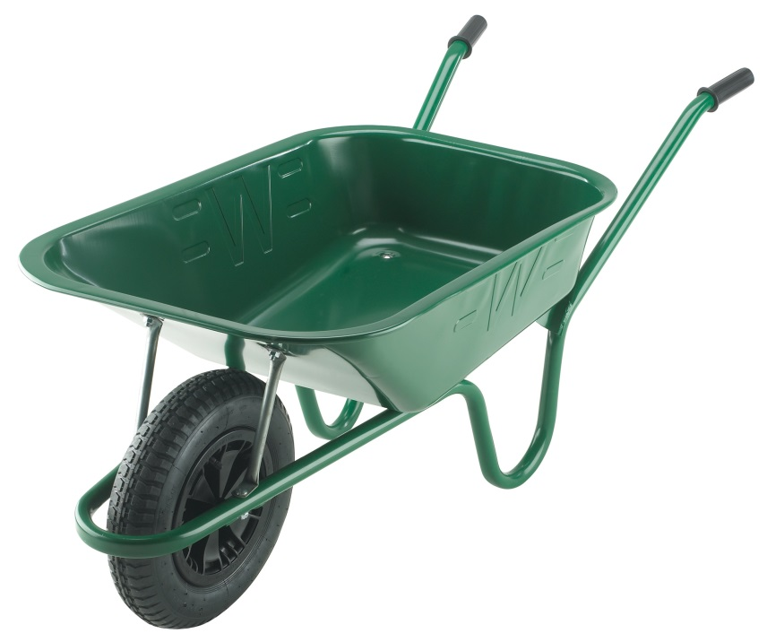 | WHEEL BARROW  - For transferring farm tools and farm produce

