June 2013

BASIC DESIGN AND TECHNOLOGY 1

(Pre-Technical Skills 1)

Objective Test

40 minutes

- Which of the stitches can be used to hold down a hem decoratively?
  - Basting
  - Hemming
  - Herringbone
  - Overcasting

- The advantage of buying food in bulk is that it
  - becomes abundant
  - becomes cheaper
  - is easier to choose
  - is easier to store

- A balanced meal must contain
  - food from each food group
  - little fat and oil only
  - protective foods only
  - protein foods only

- Drawing and painting are grouped under
  - landscape
  - still life
  - three-dimensional work
  - two-dimensional work

- Identify the drawing tool from the following items
  - Crayon
  - Paper
  - Palette
  - Ruler

The figure below is a wooden block. Use it to answer Questions 6 and 7.
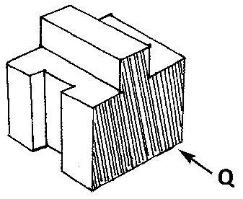

- Which of the following represents the front view in the direction of arrow Q?

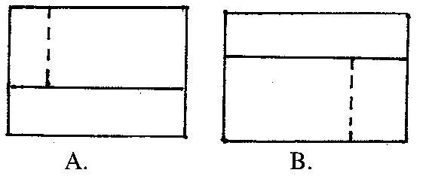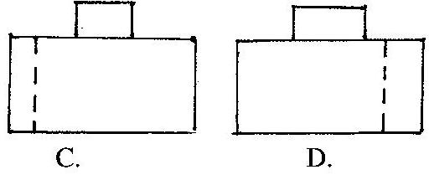

- The plan is represented by

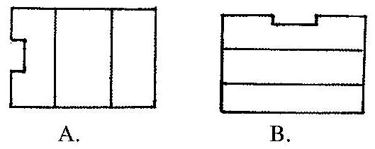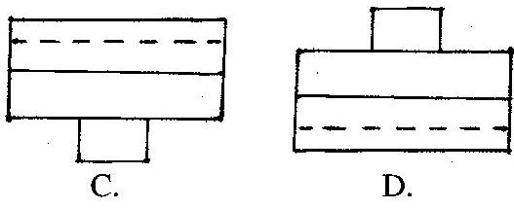

- A sole proprietor
  - shares profit with friends
  - shares profit with a partner
  - takes decisions alone
  - takes decision with his staff

- The statement describing the problem in designing is referred to as
  - design brief
  - design process
  - situation
  - investigation

- Which of the following is not a type of joint for fixing parts of furniture
  - movable joints
  - unmovable joints
  - Temporary joints
  - permanent joints

- In oblique drawing one side of the object is inclined at an angle of
  - 30°
  - 45°
  - 60°
  - 90°

- In a circuit diagram, current flows from
  - neutral to negative
  - neutral to positive
  - positive to negative
  - negative to positive

- Select a neutral colour from the options below
  - blue
  - orange
  - red
  - white

- The first step in designing is
  - choosing the right materials
  - colouring the sketches
  - identifying the problem
  - making sketch models

- A dressmaker may also be skillful in
- embroidery making
- furnishing homes beautifully
- making beautiful paintings
- selecting materials for upholstery

  - I, II and III only
  - I, II and IV only
  - I, III and IV
  - II, III and IV only

- Turpentine is mixed with
  - emulsion paint
  - lacquer
  - oil paint
  - thinner

- The elevation projected onto the side vertical plane is the
  - front
  - plan
  - end
  - back

- Which of the following is not a fastener?
  - bolts and nuts
  - soldering bits
  - screws
  - rivets

- Files are cleaned by using the
  - file card
  - hacksaw blade
  - scriber
  - chisel

- Which of the following components stores electrical charge?
  - diode
  - switch
  - resistor
  - capacitor

- The type of material used to strengthen joints in woodwork is known as
  - adhesives
  - abrasives
  - sanding sealer
  - wax polish

- Which of the following types of line is used to indicate the size of a drawing?
  - Hidden line
  - Centre line
  - Construction line
  - Dimension line

- Sandcrete bricks are made from
  - cement and clay
  - cement and sand
  - cement and laterite
  - cement and lime

- Which of the following is used to protect the head from injury?
  - apron
  - gloves
  - goggles
  - helmet

- The funnel is an example of surface development of a
  - cone
  - cylinder
  - square prism
  - square pyramid

- Which of the following tools are used for boring wood?
  - brace and bit
  - mortice chisel and mallet
  - hammer and cold chisel
  - hammer and centre punch

- The first step to be taken when checking a socket outlet for a fault is to
  - open the socket outlet
  - switch off power at the main switch
  - test the socket outlet
  - remove the main fuse

- The soft solder is an alloy of
  - copper and lead
  - copper and tin
  - lead and tin
  - lead and aluminium

- Which of the following is a cutting tool?
  - scrubbing plane
  - bench vice
  - rawhide mallet
  - soldering iron

- A face side mark on planed wood indicates that the surface
  - is smooth
  - is rough
  - has been tested for flatness
  - has been tested for squareness

